Week 4 Lab: Microservices and Cloud-Native Design

Part F - Build and run the system
Docker Compose build and running containers
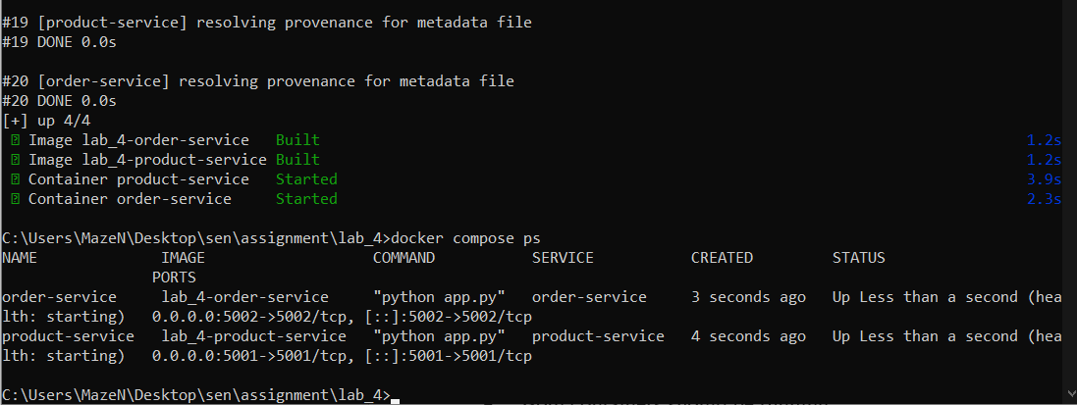
Container logs / health status
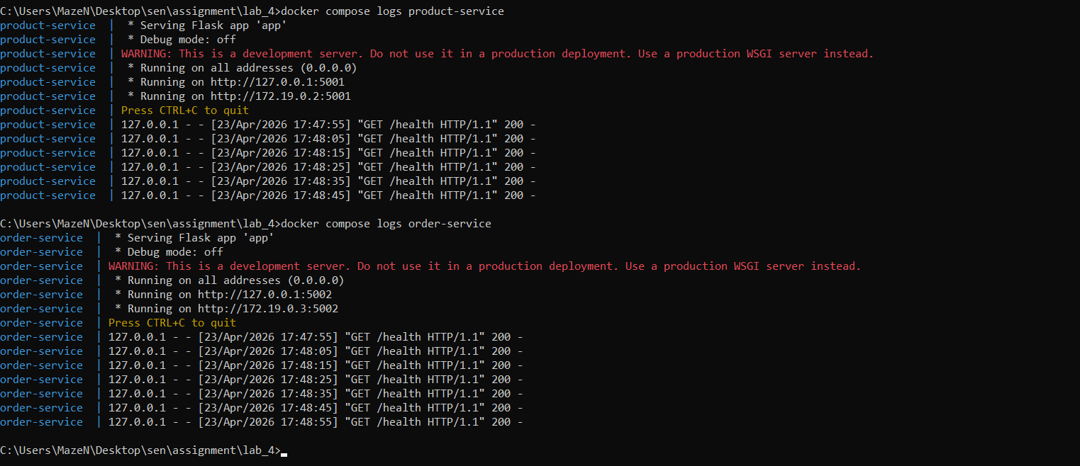

Part G - Functional testing
Successful product service testing
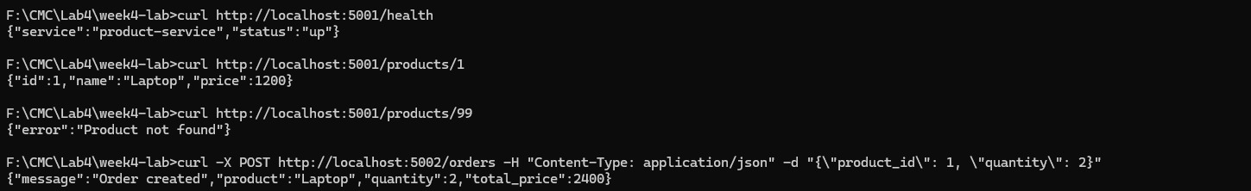
Successful order creation API response

Part H - Failure injection and resilience observation
Restarting product-service and recovery
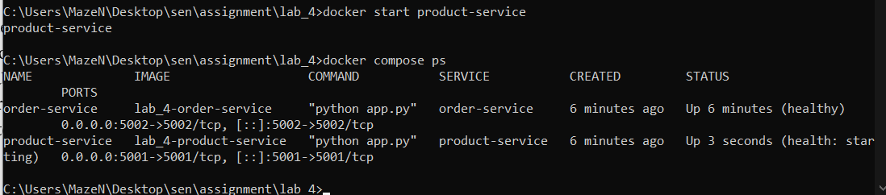

Answers to Questions
Which parts of this lab show the benefits of microservices over a monolith?
Independent services (product-service and order-service), separate Docker images, independent deployment, and clear API boundaries show better scalability, maintainability, and technology flexibility than a monolith.
Which new complexities were introduced by splitting the system into two services?
Service discovery, network communication, environment configuration, health checks, retries, logging across services, and failure handling all add operational complexity.
What would break if network latency increased or one service became slow?
Order creation would become slower because order-service depends synchronously on product-service. Timeouts may occur and users may receive 503 errors or delayed responses.
Which 12-factor app principles are visible in this implementation?
Config through environment variables, stateless processes, isolated dependencies with Docker images, parity between development/runtime environments, and logs handled as streams through container logs.

Reflection Questions
1. Microservices improve modularity and independent deployment, but increase communication overhead.
2. Docker Compose is useful for local orchestration, while Kubernetes offers stronger scaling and self-healing.
3. Health checks help detect unhealthy services automatically.
4. Restart policies improve resilience after crashes.
5. Synchronous communication is simple but creates dependency on upstream service availability.

